SCHOOL OF COMPUTER SCIENCE AND ARTIFICIAL INTELLIGENCE |  |  |  |  | DEPARTMENT OF COMPUTER SCIENCE ENGINEERING
Program Name: B. Tech |  |  |  | Assignment Type: Lab |  |  | Academic Year:2025-2026
CourseCode |  |  | 23CS002PC304 | Course Title |  | AI Assisted Coding
Year/Sem |  |  | III/II | Regulation |  | R23
Date and Day  of Assignment |  |  | Week9 – Monday | Time(s) |  | 23CSBTB01 To 23CSBTB52
Duration |  |  | 2 Hours | Applicable to  Batches |  | All batches
Assignment Number: 17.1
 | Q.No. | Question
 | 1 | Lab 17 – AI for Data Processing: Data Cleaning and Preprocessing Scripts  Lab Objectives:  - Learn how to clean raw datasets using AI-assisted Python scripting.  - Apply preprocessing techniques such as handling missing values, encoding categorical data, and normalization.  - Automate repetitive data-cleaning tasks with AI-generated code.  - Understand how preprocessing impacts model performance.  Task 1 – Customer Data Cleaning  Task:  Use AI to generate a Python script for cleaning a customer dataset.  Instructions:  - Handle missing values in columns (age, income, city).  - Remove duplicate records.  - Standardize text values (e.g., city names in lowercase).  - Encode categorical variables (gender, city).  Sample Code:  import pandas as pd  data = pd.read_csv("shopping_trends.csv")  print(data.head())  Dataset link:  https://www.kaggle.com/datasets/iamsouravbanerjee/customer-shopping-trends-dataset?select=shopping_trends.csv  Expected Output:  - A cleaned Pandas data frame ready for analysis.  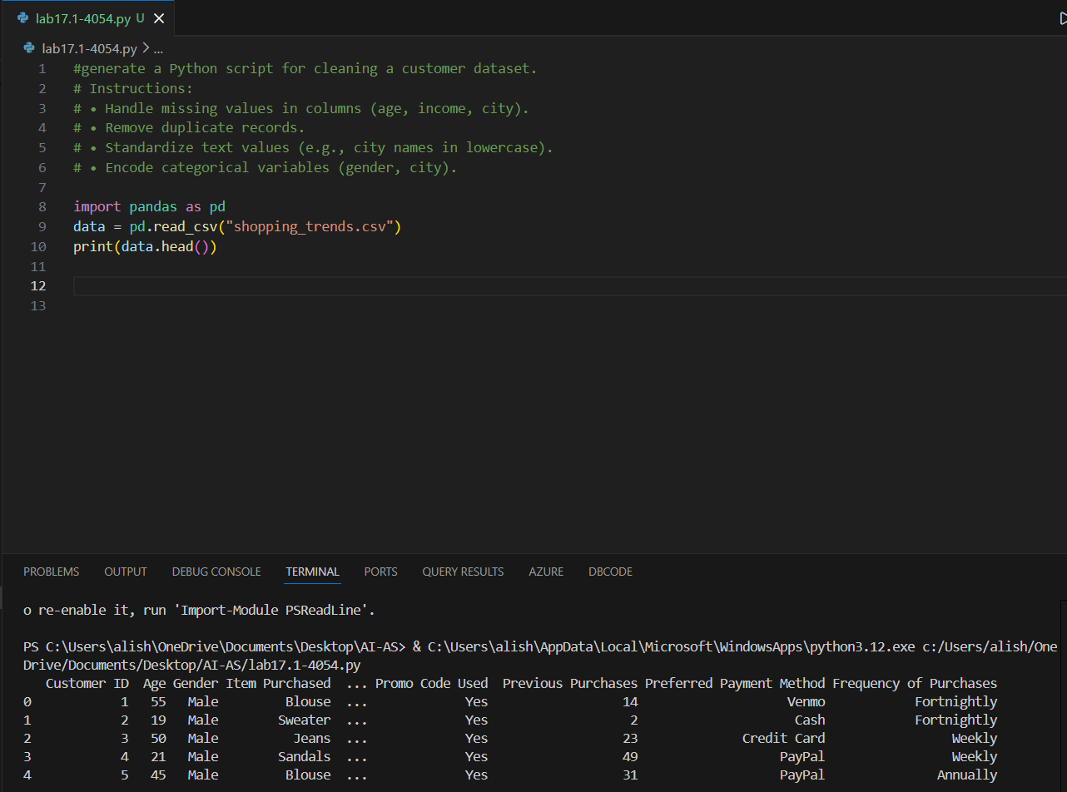  Explanation:  This code is for cleaning a customer dataset. It does the following:  1. It reads a CSV file called "shopping_trends.csv" into a DataFrame using the pandas library.  2. It prints the first few rows of the dataset to give an overview of the data.  Task 2 – Sales Data Preprocessing  Task:  Preprocess sales transaction data using AI assistance.  Instructions:  - Convert date columns into datetime format.  - Create new features (month, year, day of week).  - Normalize sales amount column.  - Detect and handle outliers in dataset.  Sample Code:  import pandas as pd  data = pd.read_csv("sales_data.csv")  print(data.head())  Dataset link:  https://www.kaggle.com/datasets/vinothkannaece/sales-dataset?select=sales_data.csv  Expected Output:  - A transformed dataset with time-based features and normalized values.  Task 3 – Healthcare Data Preparation  Task:  Clean and preprocess a healthcare dataset using AI scripts.  Instructions:  - Handle missing values in blood_pressure, cholesterol.  - Encode categorical features  - Scale numerical features (min-max or standard scaling).  - Split dataset into training and testing sets.  Dataset link :  https://www.kaggle.com/datasets/abdallaahmed77/healthcare-risk-factors-dataset  Expected Output:  - A preprocessed dataset ready for machine learning models.  Task 4 – Employee Salary Data Preprocessing  Task:  Clean and preprocess an employee salary dataset using AI scripts.  Instructions:  • Handle missing values  • Detect and remove salary outliers.  • Standardize department names (lowercase).  • Apply label encoding to job location, department.  Dataset link:  https://www.kaggle.com/code/vishantmathur/employee-salary  Expected Output:  • A structured dataset ready for HR analytics.

